The Relationship Between Microhabitat Use and Allometry Across Salamander Species

Alexa K. Head

West Virginia University Institute of Technology

Evolution (BIOL 461)

April 4, 2023

# Abstract

Several factors make salamanders an interesting topic of research in the field of evolutionary developmental biology. This paper investigates the implications of environment and lifestyle on salamanders' allometry. Specifically, the relationship between body size and tail length in different microhabitats is investigated. Analyses showed that the relationship between tail length and body size was isometric. Also, microhabitats strongly influenced body size but not tail length.

# 

# The Relationship Between Microhabitat Use and Allometry Across Salamander Species

Salamanders (clade: Caudata) are interesting creatures in that they present a unique way of studying the relationships between ecology, evolution, and development. Across Caudata, individuals exhibit a wide variation in developmental lifecycles. Individuals can genetically control a developmental process's timing, rate, or duration in response to factors such as the environment. Paedomorphism, which is the slowing down of growth rates such that there is a delay in development (Shaffer 2013), is widely seen in many salamander species. A form of paedomorphism, called neoteny, is the failure to metamorph as an evolutionary life strategy, as seen in the popular axolotl. Paedomorphic individuals develop into adults while retaining “child-like” features to speed up sexual maturity (Mitchell). Thus, salamanders such as the axolotl never metamorphosis. The opposite of paedomorphosis is the direct development strategy. Salamanders that undergo direct development skip aquatic larval stages. Instead, any pre-metamorphic development is performed within an egg, and when the egg hatches, the salamander is a fully formed adult (Scales et al. 2015). “Normal” development in salamanders includes an aquatic larval stage which then metamorphoses into a fully formed adult. Some species can undergo both normal development and paedomorphosis. This is also detailed in Table 1.

The ability of salamanders to change their lifecycle in response to different ecological variables allows them to persist in a wide range of different environments (Scales et al. 2015). It also allows an excellent opportunity for biologists to observe the selective pressures of the environment on phenotype. This paper investigates the implications of environment and lifestyle on salamanders' allometry. Specifically, we look at the relationship between body size and tail length in different microhabitats. It is hypothesized that there will be an isometric relationship between body size and tail length. That is to say, the tail length will proportionally increase as body size increases, regardless of microhabitat.

# 

# Materials and Methods

## Data Collection

The data used in this analysis, retrieved using the Dryad Digital Repository, was the same data used by Baker and Adams in their 2019 analysis which focused on arboreal salamanders in the family Plethodontidae. Microhabitats of 495 salamander species were compiled by Baker and Adams from several different published sources based on multiple classification schemes. Ultimately, the classification scheme used in this paper is the M7 classification. The M7 classification scheme includes seven different microhabitats and categorizes species based on where they spend most of their adult life (majority rule). For this assessment, the other classification schemes were not considered. The seven microhabitats utilized in this paper include the following: arboreal (A), cave (C), fossorial (F), saxicolous (S), semiaquatic (SA), terrestrial (T), and aquatic (W).

Baker and Adams also included morphological summaries of 310 species of salamanders in their dataset. Baker and Adams compiled measurements from other papers and took their own measurements using a digital camera with a macro lens. Some measurements they obtained came from museum specimens. The snout-vent length (SVL) and tail length (TL) measurements used in this analysis were parsed from this dataset. Snout-vent length, or body size, is a measurement taken from the snout's tip to the cloaca's opening. Tail length is measured from the cloaca to the end of the tail. It is important to note that Baker and Adams did not record gender and neglected sexual dimorphism. Thus, this paper also does the same.

Additionally, a summary of the different lifestyles across 571 species of salamanders was obtained by Dr. Jonathan Mitchell. This dataset assigned a ‘neotenic value’ for each species. Each value is described below in Table 1. This data was used in collaboration with that of Baker and Adams to categorize salamander species by lifestyle and microhabitat. After combining the two datasets, 260 species summaries were left to use for this analysis (with a mean of 10.22 individuals measured per species) (Baker and Adams 2019).

| Neotenic Value | Meaning | Description |
| --- | --- | --- |
| -1 | Direct development | Fully formed adult hatches from egg |
| 0 | Normal development | Metamorphosis |
| 1 | Sometimes normal, sometimes neotenic | Can be 0 or 2 depending on external factors |
| 2 | Always neotenic | Paedomorphs, such as the axolotl described above |

*Table 1:* This table summarizes the different values assigned to each lifestyle strategy used in this paper. The different lifestyle strategies are described in the introduction in greater detail.

## Data Analysis

## 

*Plot 1:*  Demonstrates the diversity of habitats exhibited by each evolutionary lifestyle strategy.

Any graphs made and all statistical analyses performed were done so in the r statistical computing environment (R Core Team 2013). To demonstrate the diversity of the data used, Plot 1 was created. Scatterplots of TL vs. SVL were made to visualize the data and assess whether or not there was a relationship between body size (SVL) and tail length (TL). Species were grouped by habitat (Plot 2. A) and lifestyle (Plot 2. B).

Based on these plots, both groupings positively correlated body size and tail length. To further investigate this, two-way ANOVAs were used to examine whether body size (Table 2) and tail length (Table 3) variation were explained by scaling (isometry) or by different ecological factors. When performing each ANOVA, the fact that the data used here is unbalanced (unequal sample sizes for each factor, as seen in Plot 2) was taken into account. Two models were considered for each ANOVA. Model one predicted there were no interactions between the two

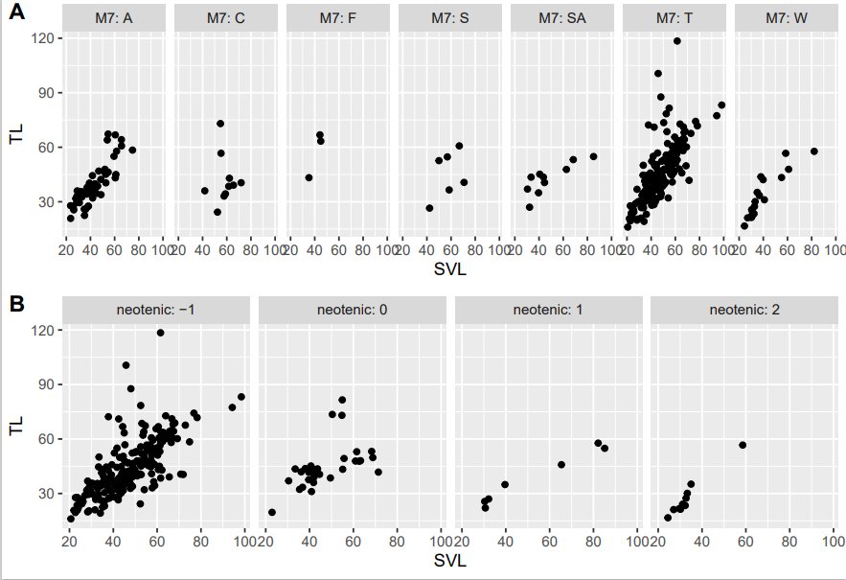

*Plot 2:* Plot 2. A is a scatterplot of snout-vent length (SVL) vs. tail length (TL). Each point is a different specie of salamander. In this plot, salamanders were separated by the microhabitats they most commonly reside in. Abbreviations for microhabitats are detailed above. Plot 2. B is the same scatterplot but instead grouped by lifestyle strategy (see Table 1 for values).

independent variables (microhabitat and lifestyle). Model two tested whether the interaction of microhabitat and lifestyle determined the dependent variable (SVL or TL). AIC (Akaike information criterion) model selection was used to determine which model best fits the data. Model one (no interaction between factors) was determined as the best fit and used in both ANOVA analyses.

Allometry between tail length and body size was investigated next. Linear regressions of log-TL with log-SVL were used to test if tail length increased with body length (Plot 3). Isometry implies that each linear morphology measurement will scale one-to-one with body

| **Dependent:**  **SVL** | **DF** | **Sum Sq** | **Mean Sq** | **F Value** | **Pr (> F)** |
| --- | --- | --- | --- | --- | --- |
| Neotenic | 3 | 2136.527 | 712.176 | 3.903 | 0.009 |
| M7 | 6 | 3011.764 | 501.961 | 2.751 | 0.013 |
| Residuals | 250 | 45452 | 181.8 |  |  |

*Table 2:* Two way ANOVA for unbalanced data. The dependent variable in this ANOVA was the SVL measurement. The two independent variables assessed were habitat and lifestyle. The model used assumes no interaction between independent variables.

| **Dependent:**  **TL** | **DF** | **Sum Sq** | **Mean Sq** | **F Value** | **Pr(>F)** |
| --- | --- | --- | --- | --- | --- |
| Neotenic | 3 | 3049.83 | 1016.61 | 4.517 | 0.004 |
| M7 | 6 | 2631.375 | 438.562 | 1.949 | 0.074 |
| Residuals | 250 | 56041 | 225.063 |  |  |

*Table 3:* Two way ANOVA for unbalanced data. The dependent variable in this ANOVA was the TL measurement. The two independent variables assessed were habitat and lifestyle. The model used assumes no interaction between independent variables.

length. Therefore, if morphological variation scales isometrically with size, we expect a log–log regression to result in a slope of one. A slope greater than one indicates hyperallometry and less than one indicates hypo allometry (Scales & Butler, 2015).

## Results

At an alpha level of 0.05, the two-way ANOVAs (Tables 2 and 3) show a statistically clear relationship between different developmental strategies, body size, and tail length. Regarding the role microhabitats play, while there is a statistically clear relationship between

environment and body size, there is no clear relationship between tail length and environment. This is also demonstrated by Plot 3. A, which shows a strong correlation between body size and 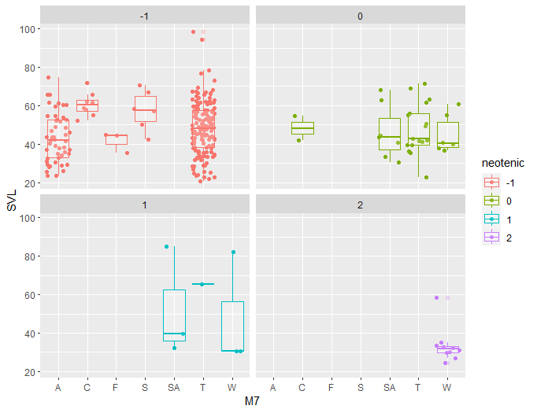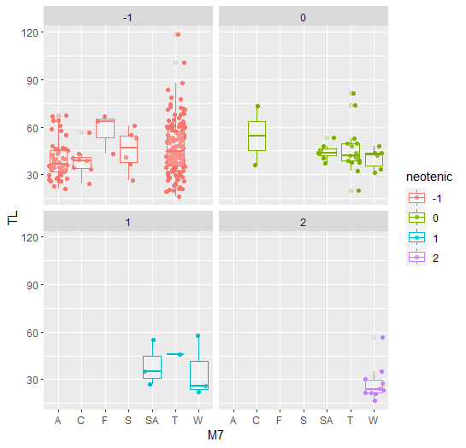

*Plot 3:* 3. A Shows the relationship between SVL and microhabitat. 3. B Shows the relationship between microhabitats and TL. Box plots represent medians with upper and lower quartiles for each ecotype.

microhabitat.

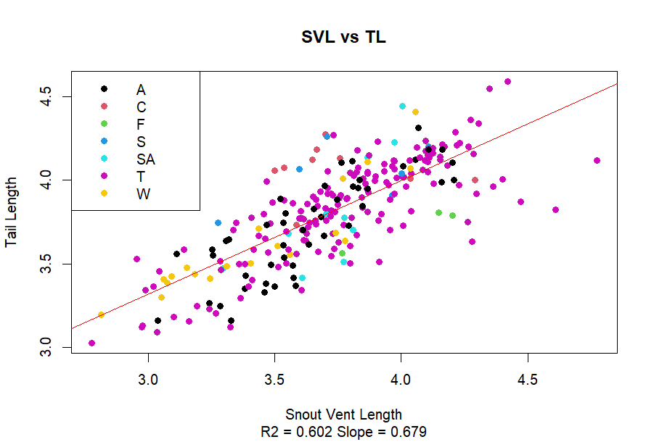

*Plot 4:* Linear regression showing a log-log analysis of SVL vs. TL. Each point represents a different species, color-coded by microhabitat. Abbreviations for microhabitats are listed above. $R^{2}$ of the model is 0.602, and the slope is 0.679.

# Discussion

The hypothesis that SVL and TL would have an isometric relationship regardless of environment was disproved. The two-way ANOVA analysis (Table 2) as well as Plot 3. A shows that there is a strong correlation between microhabitats and body size.

The slope of the log-log linear regression was less than one (0.679), indicating hypo allometry between body size and tail length (see Plot 4) across all species. In other words, as body size increased, there was a trend of reduced TL. The r-value was calculated by taking the square root of $R^{2}$. This gave an r-value of 0.775. The r-value being positive indicates a positive correlation between the two variables. The $R^{2}$ value of 0.602 percent shows that 60% of the variability in SVL is explained by the variability in TL or vice versa.

One important aspect of this experiment is that salamanders which are always neotenic (2), can only live in aqueous (W) environments. This is just one example of how neoteny and microhabitat are not independent of one another. Microhabitat directly influences what lifestyle a salamander undergoes. Plot 3 shows that salamanders that undergo direct or normal development have the most variety in ecotype.

Results from this analysis could be biased in two possible ways. The data used did not account for any sexual dimorphism. Additionally, the data was largely unbalanced. An unproportionate number of the species used were from the family Plethodontidae and are largely direct developers.

# 

# Data Availability

# RStudio (version 4.2.2 (2022-10-31 ucrt)) was used to run all tests and create all figures. Code for this analysis can be found at <https://github.com/AlexaKHead/Tasks/tree/master/Project>. The data can be found at <https://datadryad.org/stash/dataset/doi:10.5061/dryad.b554m44>.

# Acknowledgments

I would like to thank Dr. Jonathan Mitchell for his guidance throughout this project and for supplying the data on the different lifestyles of several species of salamanders. He was also a great help in figuring out the coding.

I also want to thank my cat, Piccolo, for the emotional support.

# 

# References

Baken, E., &amp; Adams, D. (2019, May 26). Macroevolution of arboreality in Salamanders. Ecology and Evolution. Retrieved April 4, 2023, from https://onlinelibrary.wiley.com/doi/10.1002/ece3.5267

Bonett, R., Ledbetter, N., Hess, A., Herrboldt, M., &amp; Denoël, M. (2021, May 15). Repeated ecological and life cycle transitions make salamanders an ideal model for evolution and development. American Association For Anatomy. Retrieved April 5, 2023, from https://anatomypubs.onlinelibrary.wiley.com/doi/10.1002/dvdy.373

Scales, J. A., &amp; Butler, M. A. (2015, May 22). The relationship between microhabitat use, allometry and ... - besjournals. British Ecological Society. Retrieved April 5, 2023, from https://besjournals.onlinelibrary.wiley.com/doi/10.1111/1365-2435.12479

Shaffer, H. B. (2013, May 1). Neoteny. Brenner's Encyclopedia of Genetics (Second Edition). Retrieved April 5, 2023, from https://www.sciencedirect.com/science/article/pii/B9780123749840010275

Mitchell, Jonathan. In-class notes from comparative anatomy (BIOL 440). West Virginia University Institute of Technology.